

Varithms (An E-learning Based Platform Specifically for Algorithms)

A Project Report submitted in partial fulfilment of the requirements for the award of the degree of
Bachelor of Technology
in
Computer Science and Engineering

by

Name of Students: Vivek Sharma, Akarsh Singh Gangwar, Akansha Saxena, Ankita Sinha, Ansh Baranwal

Under the Guidance of Mr.Amir Khan, Technical Trainer, Department of Computer Engineering & Applications

Institute of Engineering & Technology

GLA University

Mathura- 281406, INDIA

Dec, 2020


Department of Computer Engineering and Applications

GLA University, 17 km. Stone NH#2, Mathura-Delhi Road, Chaumuha, Mathura – 281406 U.P (India)

Declaration

I/we hereby declare that the work which is being presented in the B.Tech. Project “Varithms (An E-learning Based Platform Specifically for Algorithms)”, in partial fulfillment of the requirements for the award of the Bachelor of Technology in Computer Science and Engineering and submitted to the Department of Computer Engineering and Applications of GLA University, Mathura, is an authentic record of my/our own work carried under the supervision of Mr. Amir Khan, Technical Trainer, GLA University.

The contents of this project report, in full or in parts, have not been submitted to any other Institute or University for the award of any degree.

Sign ______________________ Sign ______________________
Name of Candidate: Vivek Sharma Name of Candidate: Ansh Baranwal
University Roll No.: 181500820 University Roll No.: 181500105

Sign ______________________ Sign ______________________
Name of Candidate: Akanksha Saxena Name of Candidate: Ankita Sinha
University Roll No.:181500054 University Roll No.: 181500101

Sign ______________________
Name of Candidate: Akarsh Singh Gangwar
University Roll No.:181500055

Certificate

This is to certify that the above statements made by the candidate are correct to the best of my/our knowledge and belief.

_______________________

Supervisor
Mr. Amir Khan
Technical Trainer,
GLA University

____________________ ____________________________

Project Coordinator Program Coordinator

(Mr. Mayank Srivastava) (Dr. Anant Ram)

Date:

ACKNOWLEDGEMENT

It gives me a great sense of pleasure to present the report of the Mini Project Undertaken during V Semester. This Project in itself is an acknowledgement to the inspiration, drive and technical assistance contributed to it by many individuals. This project would never have seen the light of the day without the help and guidance that we have received.

Our heartiest thanks to Mr. Amir Khan, our project supervisor, for providing us with an encouraging platform to develop this project, which thus helped us in shaping my abilities towards to a constructive goal.

His vision and execution aimed at creating a structure, definition and realism around the project and fostered the ideal environment for me to learn and do. This project is a result of his guidance, encouragement and inputs in the numerous meetings he had with us.

The experience was new and I learned many new things from here
ABSTRACT

E-Learning is the process of using technology to enhance learning and tutoring or it is a more effective way of delivering a visual and immersive learning experience on a computer or mobile device. In this new era of globalization, where digitalization is playing a pivotal role in upgrading the life of people all around the globe, whether its industrial sector, educational sector, banking sector, etc. E-learning platforms are making learning easier. E-learning is more of, out-of-classroom and in-room educational experiences imparted to the users via technology, it is more of flexible learning as it is available anytime, anywhere. Hence, we can say the E-learning platform is breaking barriers as one can learn anywhere, these platforms also lack time constraints because one can access the content available on these sites 24*7.
These e-learning platforms are rising exponentially, these platforms are even helping professionals who cannot afford the time for in-classroom teaching due to busy schedules, those professionals to get themselves equipped with the knowledge they want to seek. For developing countries like India who are progressing towards E-Governance and education, these e-learning platforms are working as a boon. In this new era of Electronics, we know the concept of e-learning, which is helping us minimize the use of pen and paper. There are many benefits of e-learning platforms like easy sharing of data and information.
Our E-Learning platform will impart knowledge related to Algorithms, how they are implemented, and what are the advantages attached to these algorithms.
We have designed this platform to make Algorithms learning more interesting, effective, and efficient. As far as we believe, smart learning is the demand of the hour. We are dedicated to providing you the best of knowledge keeping all your placement requirements in mind. Our main concern here is not only to provide you with all the algorithms to study but also to make things a lot simpler for the students. Minimizing your struggle while understanding them.

CONTENTS

Declaration
Certificate
Acknowledge
Abstract
1. Introduction
  - Background of the topic
  - Motivation and Overview
  - Objective
  - Software Development Model
  - Requirements
- Technology Used

  - HTML

  - CSS

  - JavaScript

  - Firebase

  - Visual Studio Code

  - GCP

  - Flutter
  - Dart

  - Adobe xD

  - Adobe Photoshop

  - Figma

Software Requirement Analysis
  - Define the problem
  - Define the modules and their functionalities (SRS)

Software Design
  - Use case Diagram
  - Data Flow Diagram
  - Entity-relationship Diagram

Implementation and User Interface
  - User Interface Design

    - Splash Screen

    - User SignUp UI

    - User login UI

    - DashBoard UI

    - Studying Algo UI
    - Profile Activity

Some Screen shots

- Software Testing

- Conclusion

- Reference

We’re here to provide you with simpler techniques to understand a particular algorithm and to implement it.

Introduction

Background of the topic

E-Learning is the process of using technology to enhance learning and tutoring or it is a more effective way of delivering a visual and immersive learning experience on a computer or mobile device. These e-learning platforms are rising exponentially, these platforms are even helping professionals who cannot afford the time for in-classroom teaching due to busy schedules, those professionals to get themselves equipped with the knowledge they want to seek.
Hypertext Markup Language (HTML) is the standard markup language for documents designed to be displayed in a web browser. It can be assisted by technologies such as Cascading Style Sheets (CSS) and scripting languages such as JavaScript. Others may include Angular, React, Node.JS.
Web browsers receive HTML documents from a web server or local storage and render the documents into multimedia web pages. HTML describes the structure of a web page semantically and originally included cues for the appearance of the document.
HTML elements are the building blocks of HTML pages. With HTML constructs, images and other objects such as interactive forms may be embedded into the rendered page. HTML provides a means to create structured documents by denoting structural semantics for text such as headings, paragraphs, lists, links, quotes, and other items. HTML elements are delineated by tags, written using angle brackets. Tags such as <img /> and <input /> directly introduce content into the page. Other tags such as <p> surround and provide information about document text and may include other tags as sub-elements. Browsers do not display the HTML tags but use them to interpret the content of the page.

Motivation and Overview

The E-learning platforms are more empowering, effective, efficient, and economical. Initially, when these platforms started developing they were based on Computer-based
learning (CBL), the role of the e-learning system for which they were developed was to impart knowledge in a more efficient method. Later on, these platforms developed which were based on Computer-supported collaborative learning (CSCL) which refers to the activity of peers interacting with each other for learning and with the support of information and communication technologies (ICT). Nowadays, it is an increasing trend to create virtual learning environments(VLE) as they are more efficient, effective, and economical.
Drawbacks of Existing System :
    - They are less efficient, as they are using the orthodox method of teaching.
    - Most of the e-learning platforms are paid, not everybody can afford it.
    - They are not able to provide information in an effective manner Need for new System :
    - To make the e-learning process faster
    - Reduce the time for E-learning
    - To move towards digitalization and reduce paper use
    - To make learning more interesting.

Objective
We have designed this platform to make Algorithms learning more interesting, effective, and efficient.
As far as we believe, smart learning is the demand of the hour. We are dedicated to providing you the best of knowledge keeping all your placement requirements in mind. Our main concern here is not only to provide you with all the algorithms to study but also to make things a lot simpler for the students. Minimizing your struggle while understanding them.
We’re here to provide you with simpler techniques to understand a particular algorithm and to implement it. For that, we will be your companion throughout your journey towards your ultimate goal which is to achieve placement in your dream company. Before making this platform work well for you guys we as a team have done lots of research and found out that there are very few platforms doing this for you. Keeping all these things in mind we will provide you with the best content and guidance. Due to this pandemic, a lot of platforms have come up so you need to make a wise choice for yourself, seeing all the facilities a platform provides you with.

Software Development Model:

For this project, we will be using the Agile Software Development Model. A brief introduction is given
below :

Agile Software Development Model:
In software development, agile (sometimes written Agile) approaches development requirements and solutions through the collaborative effort of self-organizing and cross-functional teams and their customer(s)/end user(s). It advocates adaptive planning, evolutionary development, early delivery, and continual improvement, and it encourages flexible responses to change. It was popularized by the Manifesto for Agile Software Development. The values and principles espoused in this manifesto were derived from and underpin a broad range of software development frameworks, including Scrum and Kanban. While there is much anecdotal evidence that adopting agile practices and values improves the agility of software professionals, teams, and organizations, some empirical studies have disputed that evidence.

Requirements

Software Requirements:
- Android Studio 3.5
- Java Development Kit 11
- Flutter SDK 1.17(Stable), Dart SDK
- Google FireAuth, FireStore, Firebase Hosting, and Testing
- Dart, Kotlin, Swift, XML, HTML5, JavaScript, CSS, BootStrap, jQuery
- Google Firebase
- Adobe xD and Figma
- Google Chrome 86

Hardware Requirements:
- Intel Core i5 or AMD FX-4300
- Microsoft® Windows® 7/8/10 (64-bit) / GNOME or KDE
- desktop. Tested on Linux based on Debian.
- 4 GB of RAM
- Huawei Honor 20i (Android) and Apple iPhone 7 [For
- on-Device Testing]
- 4 GB of available disk space minimum (500 MB for IDE + 1.5
- GB for Android SDK and emulator system image)
- 1280 x 800 minimum screen resolution.

Technology Used

HTML

Hypertext Markup Language (HTML) is the standard markup language for documents designed to be displayed in a web browser. It can be assisted by technologies such as Cascading Style Sheets (CSS) and scripting languages such as JavaScript.
Web browsers receive HTML documents from a web server or local storage and render the documents into multimedia web pages. HTML describes the structure of a web page semantically and originally included cues for the appearance of the document. HTML elements are the building blocks of HTML pages. With HTML constructs, images and other objects such as interactive forms may be embedded into the rendered page. HTML provides a means to create structured documents by denoting structural semantics for text such as headings, paragraphs, lists, links, quotes, and other items. HTML elements are delineated by tags, written using angle brackets. Tags such as <img /> and <input /> directly introduce content into the page. Other tags such as <p> surround and provide information about document text and may include other tags as sub-elements. Browsers do not display the HTML tags but use them to interpret the content of the page.
HTML can embed programs written in a scripting language such as JavaScript, which affects the behavior and content of web pages. The inclusion of CSS defines the look and layout of content. The World Wide Web Consortium (W3C), the former maintainer of the HTML and current maintainer of the CSS standards, has encouraged the use of CSS over explicit presentational HTML since 1997.

CSS

Cascading Style Sheets (CSS) is a style sheet language used for describing the presentation of a document written in a markup language like HTML. CSS is a cornerstone technology of the World Wide Web, alongside HTML and JavaScript.
CSS is designed to enable the separation of presentation and content, including layout, colors, and fonts. This separation can improve content accessibility, provide more flexibility and control in the specification of presentation characteristics, enable multiple web pages to share formatting by specifying the relevant CSS in a separate .css file which reduces complexity
and repetition in the structural content as well as enabling the .css file to be cached to improve the page load speed between the pages that share the file and its formatting.
Separation of formatting and content also makes it feasible to present the same markup page in different styles for different rendering methods, such as on-screen, in print, by voice (via speech-based browser or screen reader), and on Braille-based tactile devices. CSS also has rules for alternate formatting if the content is accessed on a mobile device.
The name cascading comes from the specified priority scheme to determine which style rule applies if more than one rule matches a particular element. This cascading priority scheme is predictable. The CSS specifications are maintained by the World Wide Web Consortium (W3C). Internet media type (MIME type) text/CSS is registered for use with CSS by RFC 2318 (March 1998). The W3C operates a free CSS validation service for CSS documents

JavaScript

JavaScript, often abbreviated as JS, is a programming language that conforms to the ECMAScript specification. JavaScript is high-level, often just-in-time compiled, and multi-paradigm. It has curly-bracket syntax, dynamic typing, prototype-based object-orientation, and first-class functions.
Alongside HTML and CSS, JavaScript is one of the core technologies of the World Wide Web. JavaScript enables interactive web pages and is an essential part of web applications. The vast majority of websites use it for client-side page behavior, and all major web browsers have a dedicated JavaScript engine to execute it. As a multi-paradigm language, JavaScript supports event-driven, functional, and imperative programming styles. It has application programming interfaces (APIs) for working with text, dates, regular expressions, standard data structures, and the Document Object Model (DOM). However, the language itself does not include any input/output (I/O), such as networking, storage, or graphics facilities, as the host environment (usually a web browser) provides those APIs.
JavaScript engines were originally used only in web browsers, but they are now embedded in some servers, usually via Node.js. They are also embedded in a variety of applications created with frameworks such as Electron and Cordova.
Although there are similarities between JavaScript and Java, including language name, syntax, and respective standard libraries, the two languages are distinct and differ greatly in design.

Firebase

Firebase is a platform developed by Google for creating mobile and web applications. It was originally an independent company founded in 2011. In 2014, Google acquired the platform and it is now their flagship offering for app/website development. Firebase gives you a platform to build, improve, and grow your app. It is a cloud platform that provides Backend as a service (BaaS).
Firebase gives the functionality to register and authenticate your users and save their data in the JSON format. It also provides the feature to upload your data into the database and retrieve it as per your requirement.

Visual Studio Code

Visual Studio Code is a free source-code editor made by Microsoft for Windows, Linux, and macOS. Features include support for debugging, syntax highlighting, intelligent code completion, snippets, code refactoring, and embedded Git. Users can change the theme, keyboard shortcuts, preferences, and install extensions that add additional functionality.
Visual Studio Code's source code comes from Microsoft's free and open-source software VSCode project released under the permissive Expat License, but the compiled binaries are freeware for any use.
In the Stack Overflow 2019 Developer Survey, Visual Studio Code was ranked the most popular developer environment tool, with 50.7% of 87,317 respondents reporting that they use it.

GCP

Google Cloud Platform is a set of Computing, Networking, Storage, Big Data, Machine Learning and Management Services provided by Google that runs on the same Cloud
infrastructure that Google uses internally for its end-user products such as Google Search, Gmail, Google Photos, and YouTube

Flutter

Flutter is a free and open-source mobile UI framework created by Google and released in May 2017. It allows you to create native mobile applications with only one codebase. This means that you can use one programming language and one codebase to create two different apps. (For iOS and Android)

Flutter consists of two parts:

- An SDK (Software Development Kit)
- A Framework

To develop with Flutter you will use a programming language called Dart. The Language was created by Google in October 2011.
Dart focuses on front-end development, and you can use it to create Mobile and Web Applications.

Dart

Dart is a client-optimized programming language for apps on multiple platforms. It is developed by Google and is used to build mobile, desktop, server, and web applications. Dart is an object-oriented, class-based, garbage-collected language with C-style syntax. Dart can compile to either native code or JavaScript.

Software Requirement Analysis

Problem Statement

The E-learning platforms are more empowering, effective, efficient, and economical. Initially, when these platforms started developing they were based on Computer-based learning (CBL), the role of the e-learning system for which they were developed was to impart knowledge in a more efficient method.
Drawbacks of Existing System :
    - They are less efficient, as they are using the orthodox method of teaching.
    - Most of the e-learning platforms are paid, not everybody can afford it.
    - They are not able to provide information in an effective manner Need for new System :
    - To make the e-learning process faster
    - Reduce the time for E-learning
    - To move towards digitalization and reduce paper use
    - To make learning more interesting.

Modules
The project will consist of various modules, each module having lots of functionalities :

Login Module :
- Will allow users to log in to access their profile.
- Will allow users to sign up for a new account
- Easy Access through various providers including Facebook and Google.
- Users can also use their phone numbers to receive an OTP and log in.

Learning Module:
- Users can understand various algorithms by reading out the simplified core concept.
- Interactive examples for better understanding.
- Text-to-Speech Services for the reading content included.
- Testing services to check the progress and understanding

Searching Module:

- Efficiently search across hundreds of algorithms(Implementation Of TRIE algorithm)
- Categorical Searching.

Recommendation Module:
- Recommending what to learn next based on previous categories
- Recommending next to learn based on popularity Recommending next to learn based on usability.

Software Design

Use Case Diagram
Use case diagram is the first step of software requirement analysis to final achievement, and it expresses how people use a system. The use case shows users, what kind of service users require, and services are offered by clients to the system. It helps the client to have a better understanding of functions in these elements and also benefits developers to achieve them. The use case diagram is commonly used to describe the system and subsystem.
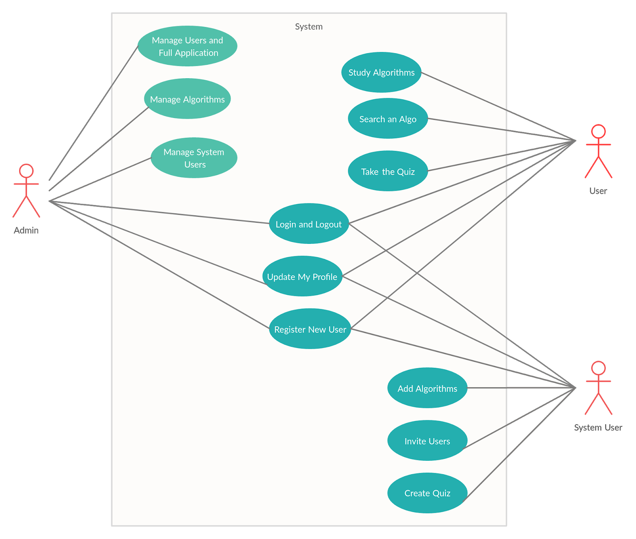

Data Flow Diagram (DFD)

A data-flow diagram is a way of representing a flow of data through a process or a system (usually an information system). The DFD also provides information about the outputs and inputs of each entity and the process itself. A data-flow diagram has no control flow, there are no decision rules and no loops. Specific operations based on the data can be represented by a flowchart.

Level 0 DFD

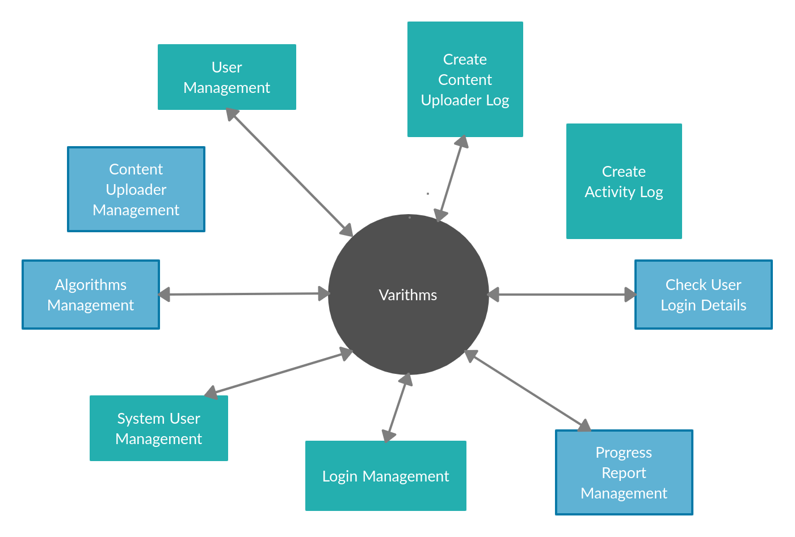

Level - 0 Data Flow Diagram

Level 1 DFD

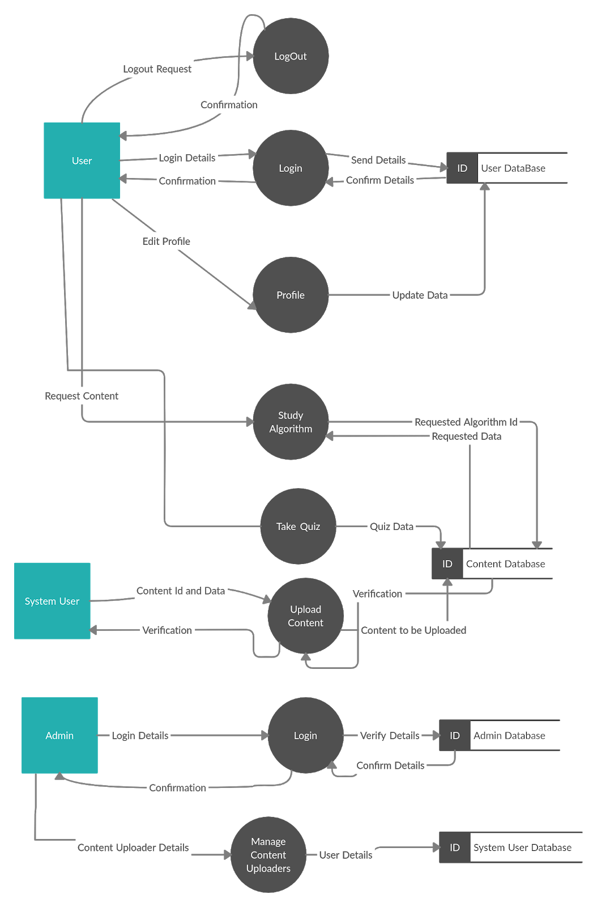
Level-1 Data Flow Diagram
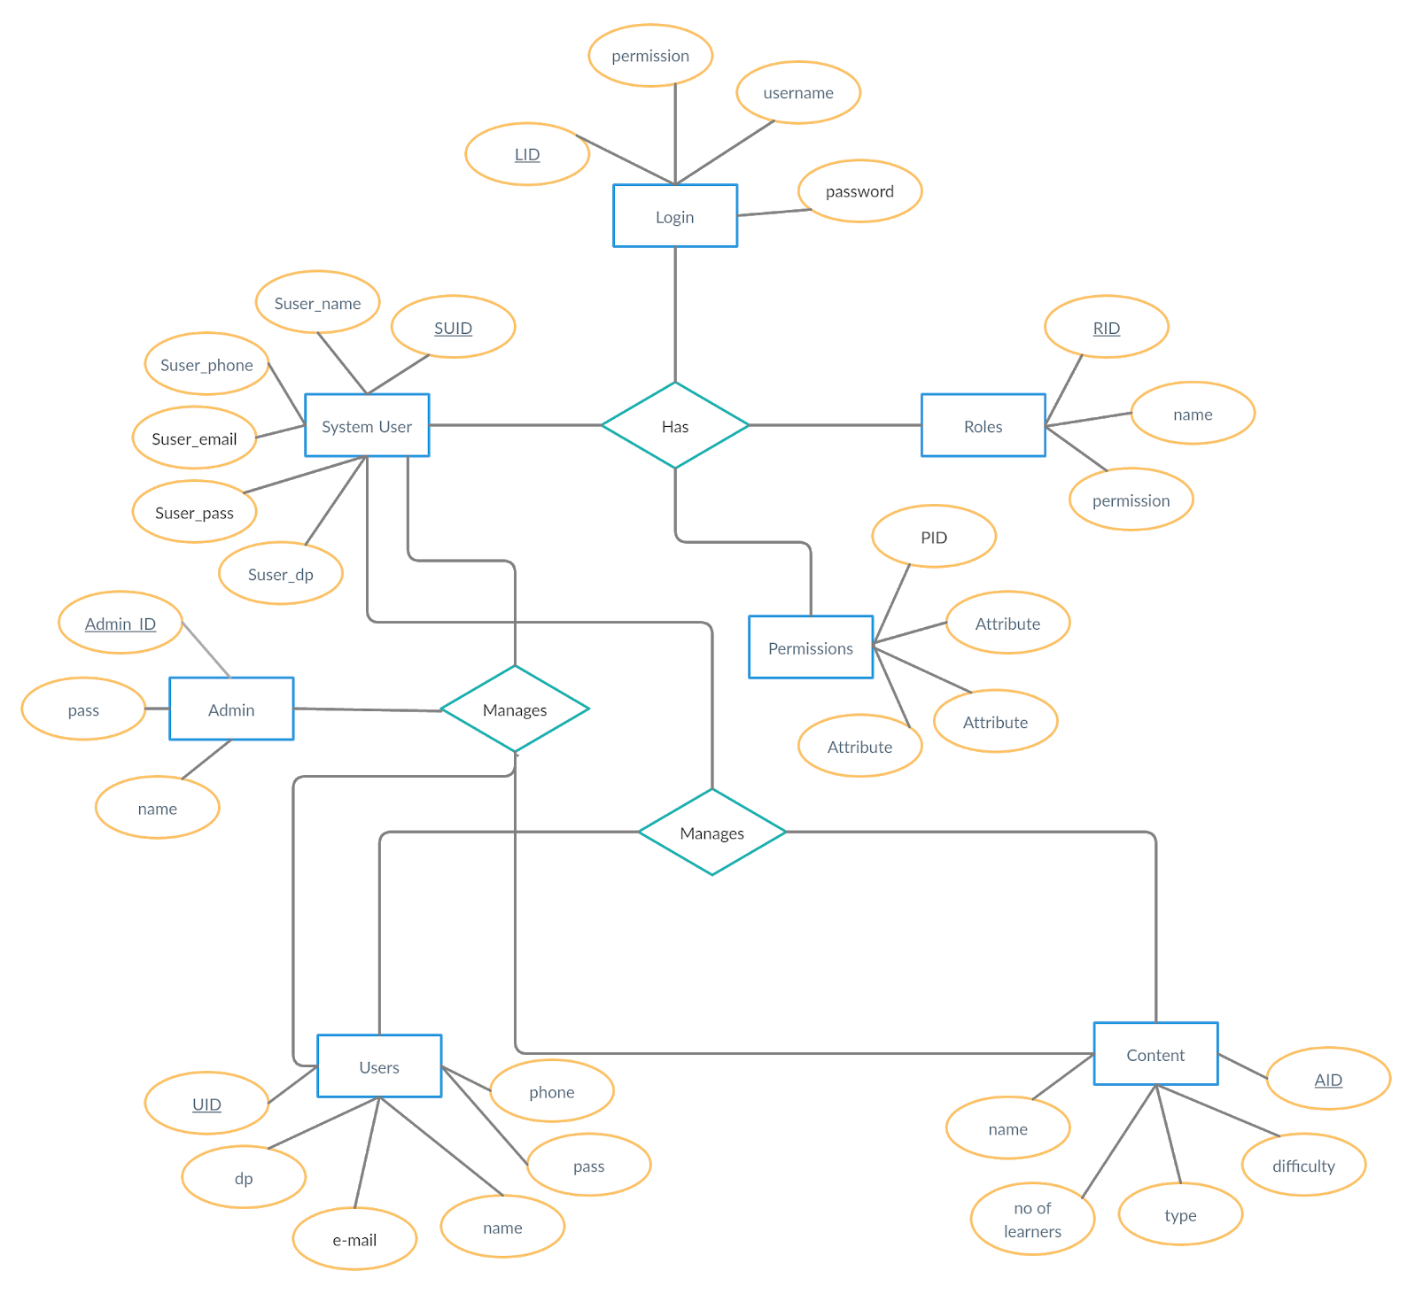
  - Entity-Relationship (ER) Diagram

Implementation and User Interface
In this section, I will discuss some important parts of implementation in this site. They are critical functions that make the system run smoothly.

User Interface Design

A user interface (UI) is the space where interactions between humans and machines occur. The goal of this interaction is to allow effective operation and control of the machine from the human end, whilst the machine simultaneously feeds back information that aids the operators' decision-making process. The goal of user interface design is to produce a user interface that makes it easy, efficient, and enjoyable (user-friendly) to operate a machine in the way which produces the desired result.

Splash Screen

This is the first thing that is visible to users while entering the website. It is used to cover up the delay caused by the on-Load methods and also for displaying the logo in general.

User SignUp UI

This is the UI design for the user registration where a user needs to enter the required credentials and the relevant data to build up his/her profile.

User Login UI

This is the interface for the user login where a user needs to enter his registered email address and password.

DashBoard UI

This is the first screen visible to the logged-in user where all the algorithm types and algorithms that are in trend are shown and the user can navigate to all the other activities through this activity.

Studying Algo UI

This is the screen where the related content i.e. explanations regarding the algo, its implementation in both major languages i.e. Java and Python come.

Profile Activity

This is the design of the profile activity where all the algorithms studied by the user are shown, besides this, the number of algorithms up to now and the profile data is also shown.

- Some Screenshots

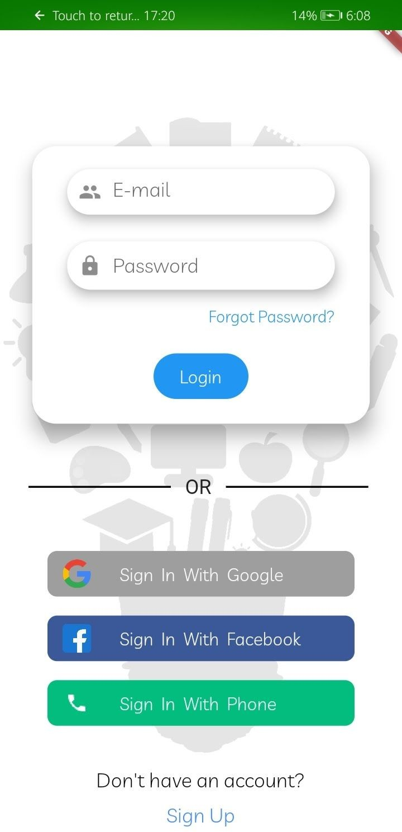
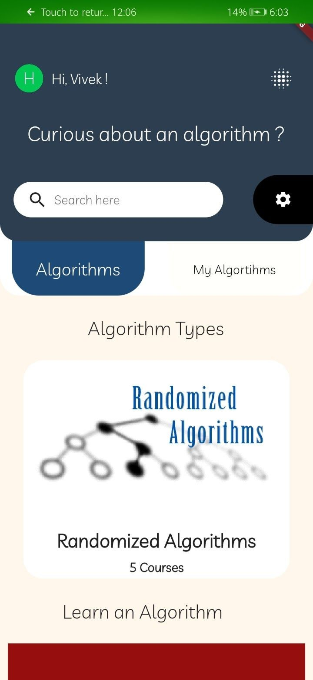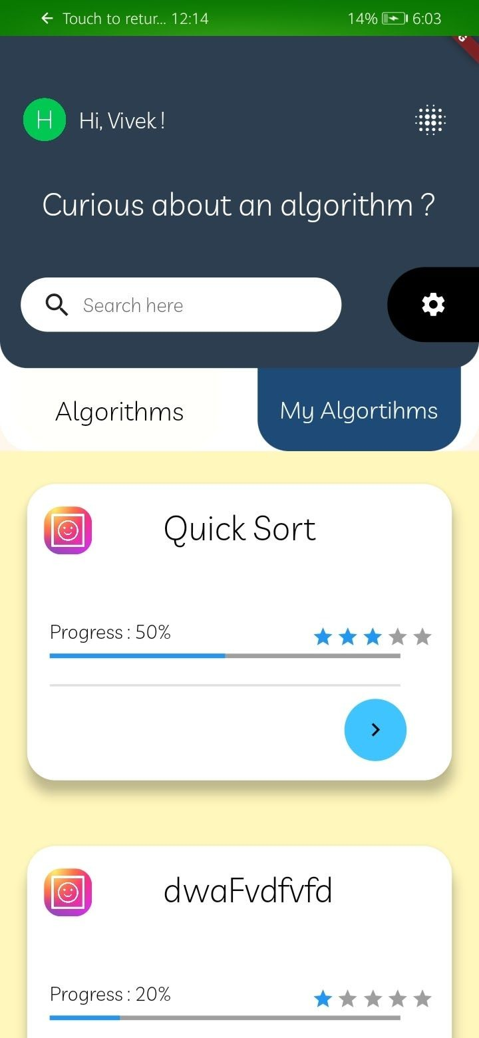
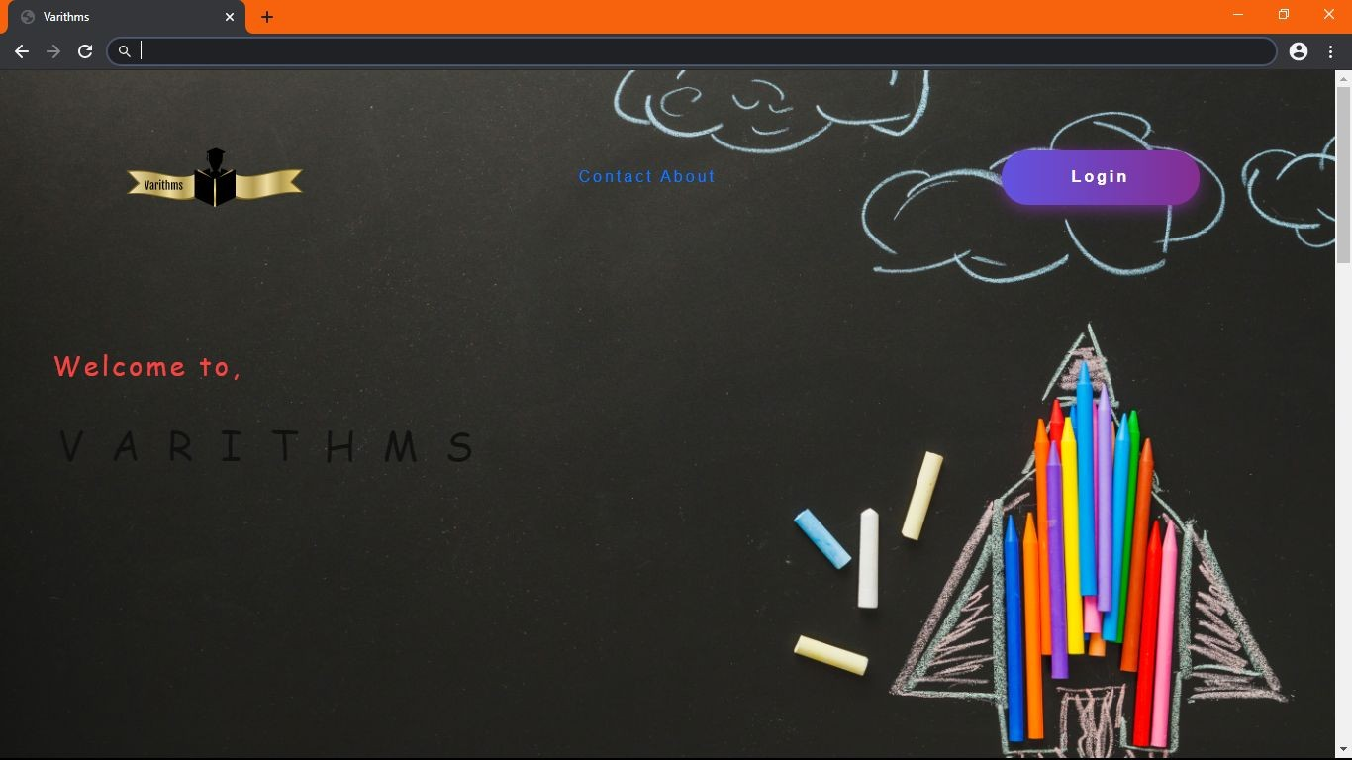

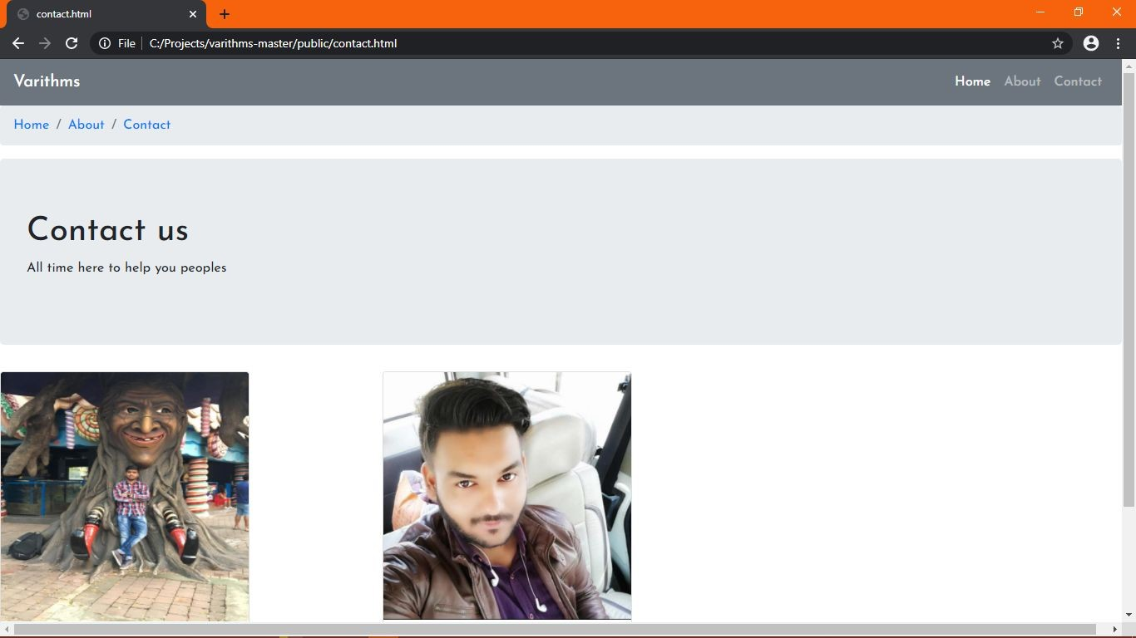
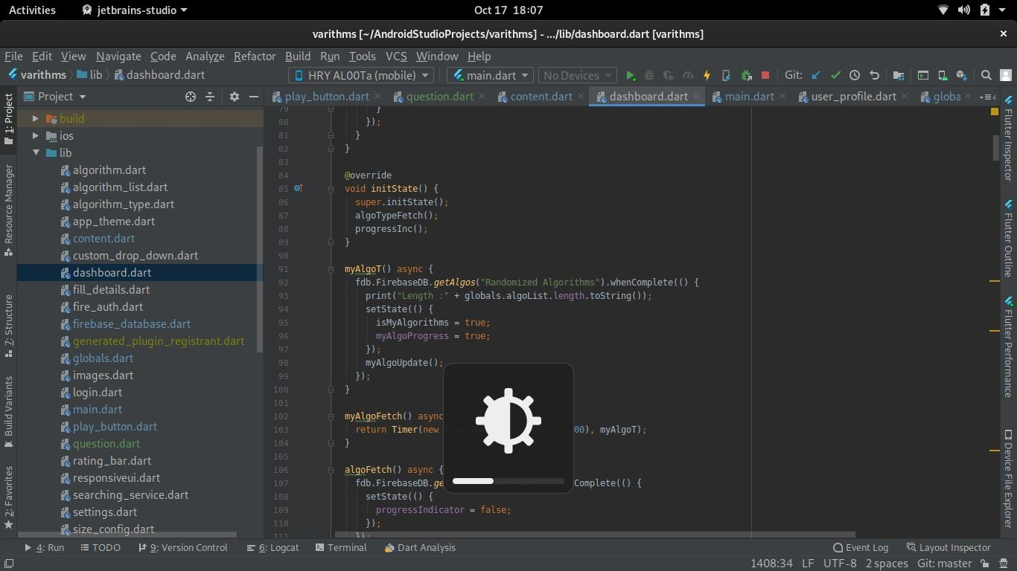
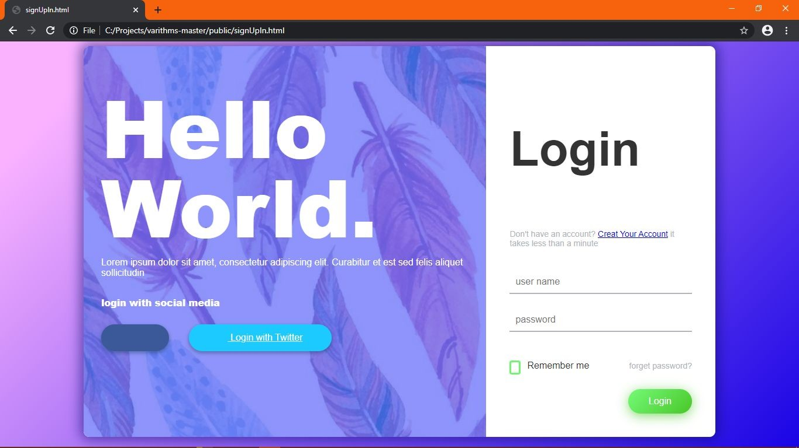
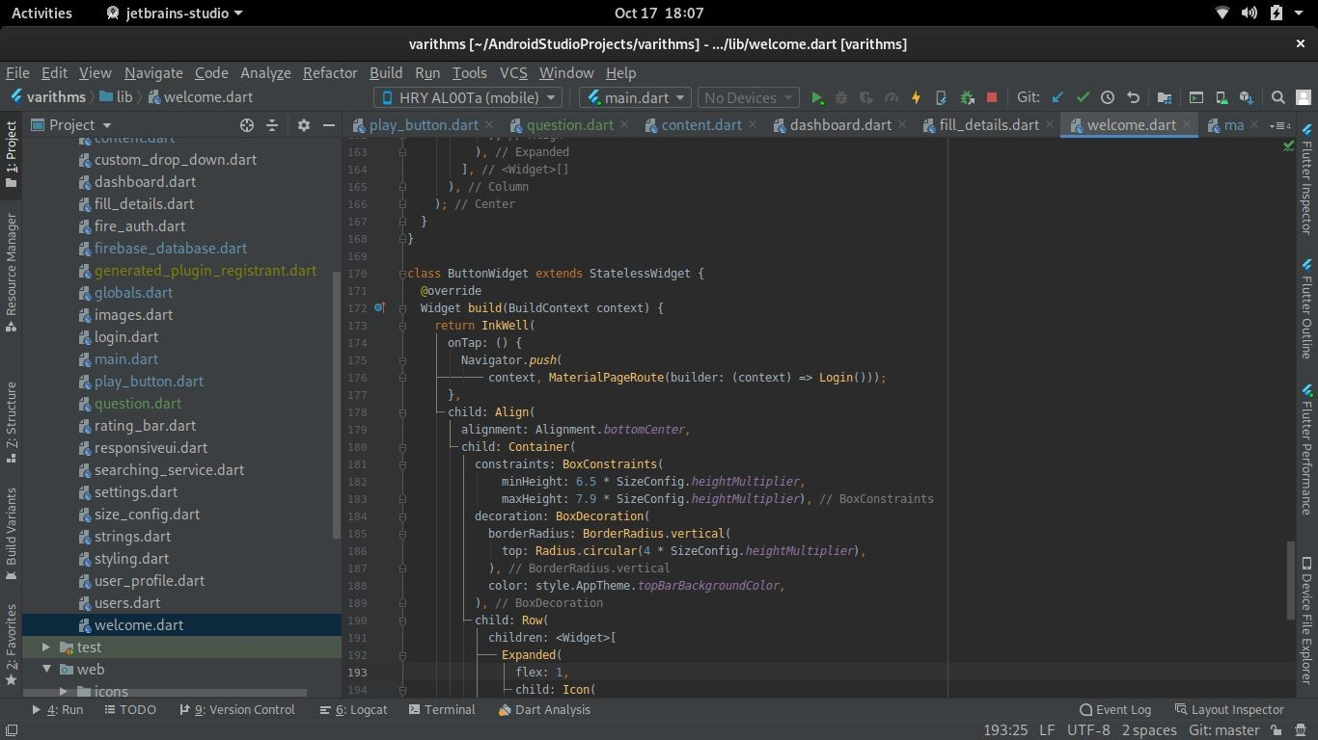
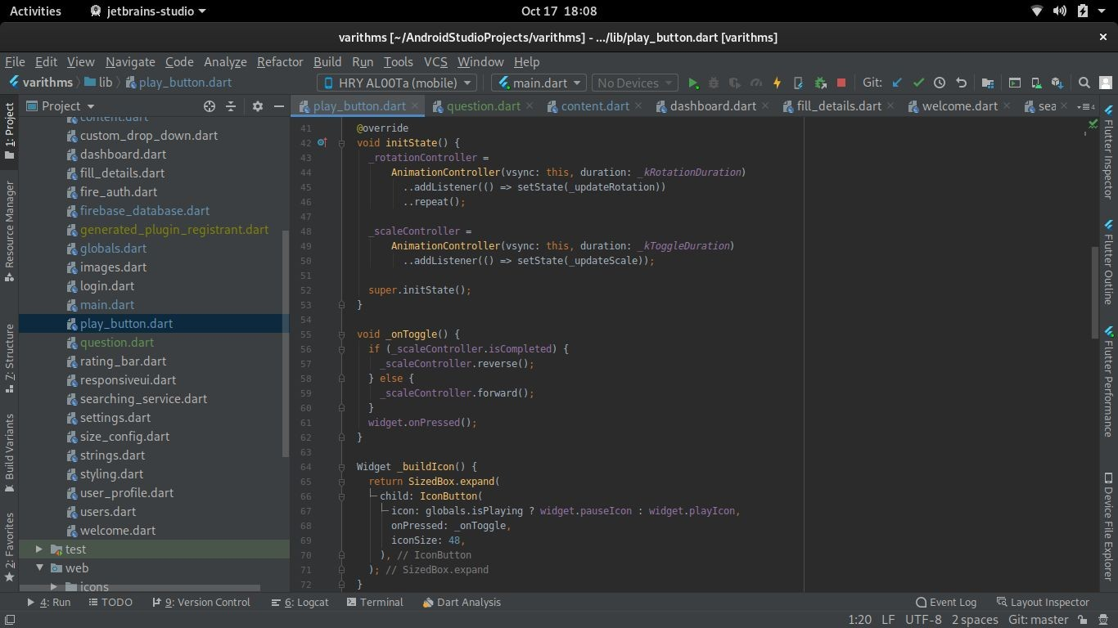
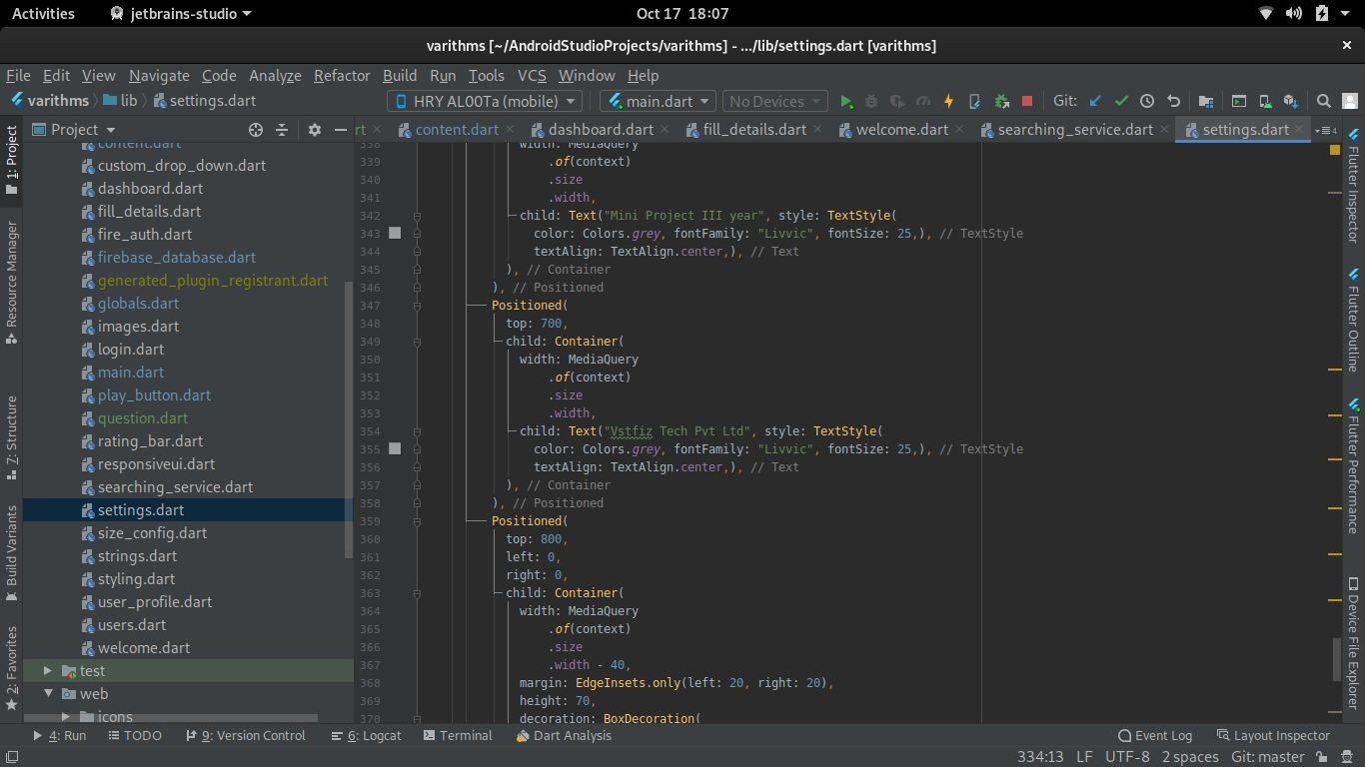
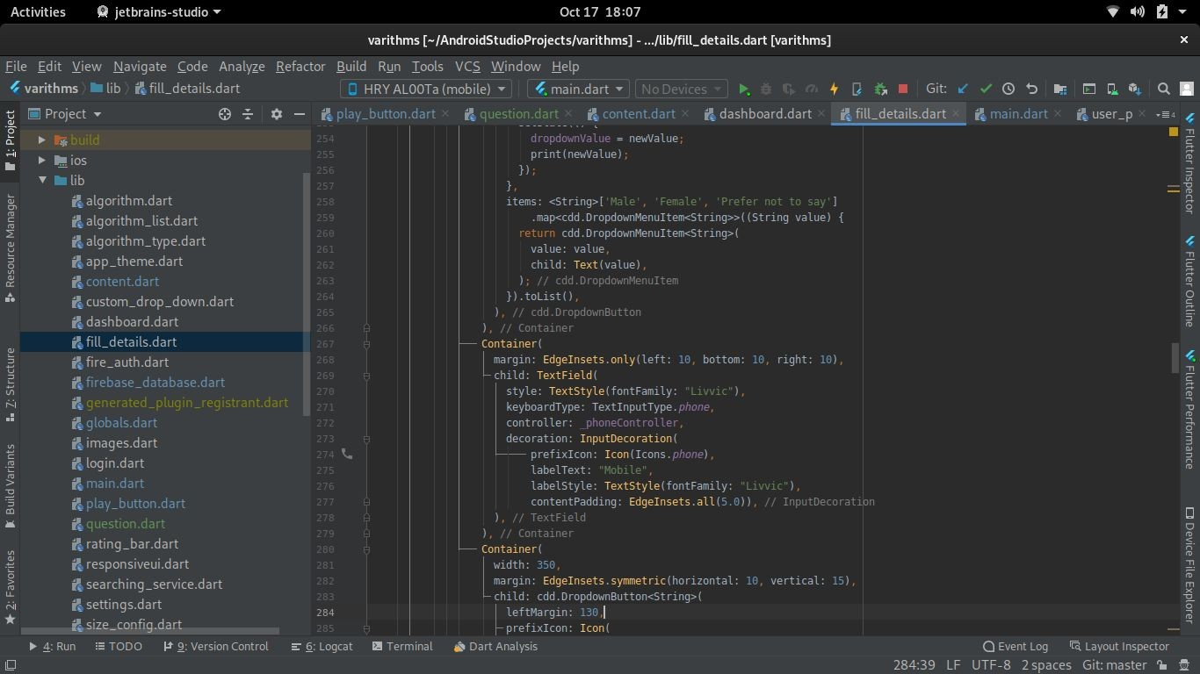
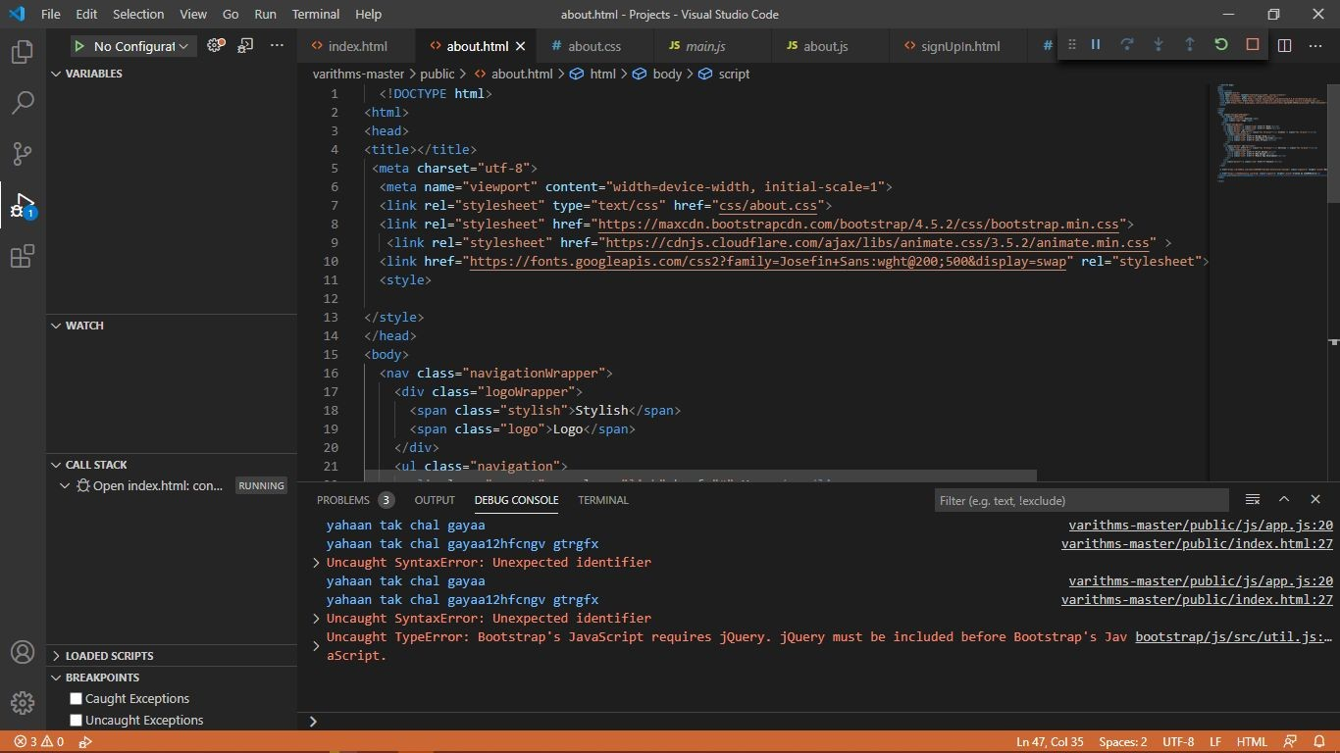
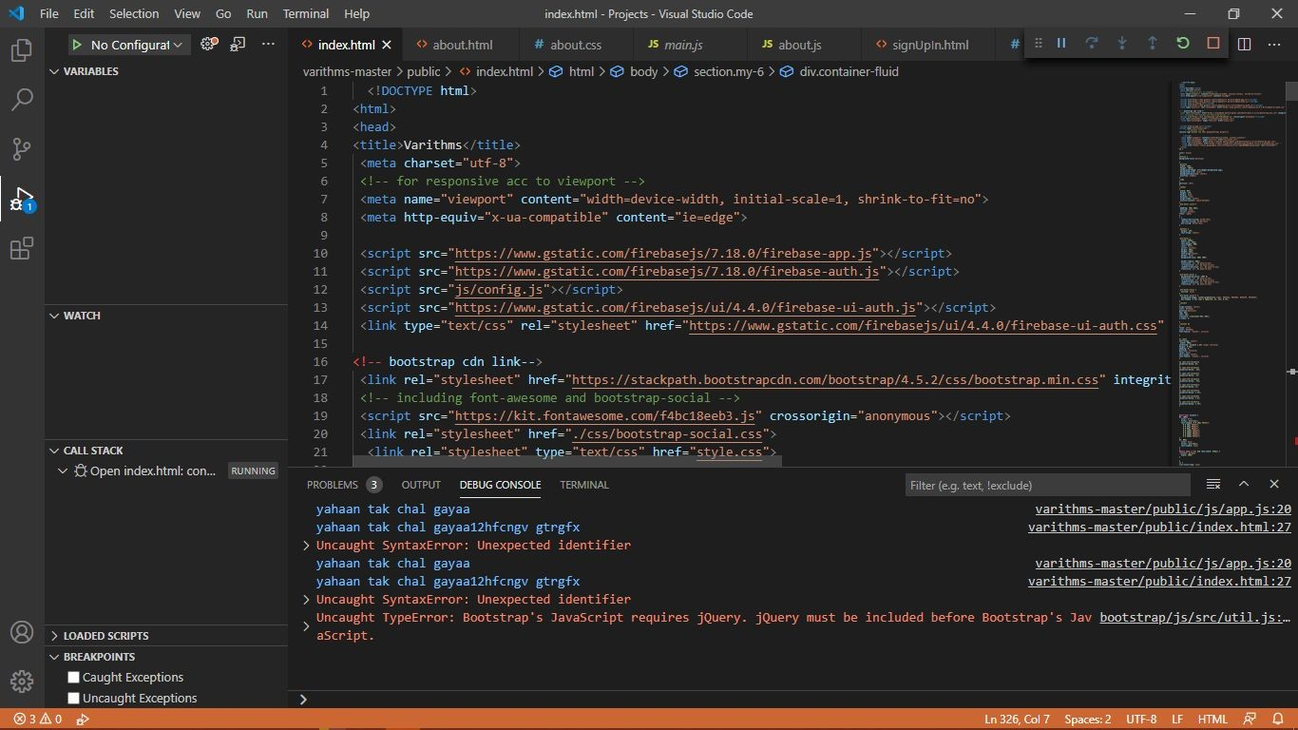

7. Software Testing

7.1 Testing:

Software testing is the process of executing a program with intension of finding errors in the code. It is a process of evolution of system or its parts by manual or automatic means to verify that it is satisfying specified or requirements or not.

Generally, no system is perfect due to communication problems between user and developer, time constraints, or conceptual mistakes by developer.

To purpose of system testing is to check and find out these errors or faults as early as possible so losses due to it can be saved.

Testing is the fundamental process of software success.

Testing is not a distinct phase in system development life cycle but should be applicable throughout all phases i.e. design development and maintenance phase.

Testing is used to show incorrectness and considered to success when an error is detected.

7.2 Objectives of Software Testing:

- Software Quality Improvement:

The computer and the software are mainly used for complex and critical applications and a bug or fault in software causes severe losses. So a great consideration is required for checking for quality of software.

- Verification and Validation:

- Verification means to test that we are building the product in right way .i.e. are we using the correct procedure for the development of software so that it can meet the user requirements.
- Validation means to check whether we are building the right product or not.
- Software Reliability Estimation: The objective is to discover the residual designing errors before delivery to the customer. The failure data during process are taken down in order to estimate the software reliability.

7.3 Principles of Software Testing:
- All tests should be traceable to end user requirements.
- Tests should be planned long before testing begins.
- Testing should begin on a small scale and progress towards testing in large.
- To be most effective testing should be conducted by an independent third party.

The primary objective for test case design is to derive a set of tests that has the highest livelihood for uncovering defects in software. To accomplish this objective two different categories of test case design techniques are used. They are:

- White box testing.
- Black box testing.

7.3.1 White-box testing:

White box testing focuses on the program control structure. Test cases are derived to ensure that all statements in the program have been executed at least once during testing and that all logical conditions have been executed.

7.3.2 Black-box testing:

Black box testing is designed to validate functional requirements without regard to the internal workings of a program. Black box testing mainly focuses on the information domain of the software, deriving test cases by partitioning input and output in a manner that provides through test coverage. Incorrect and missing functions, interface errors, errors in data structures, error in functional logic are the errors falling in this category.

Software Testing is Important because:

If there are any bugs or errors in the software, it can be identified early and can be solved before delivery of the software product. Properly tested software product ensures reliability, security and high performance which further results in time saving, cost effectiveness and customer satisfaction.

8. Conclusion

As a conclusion, we can say that this project period was a great experience. Thanks to our amazing guide during the project we acquired deeper knowledge concerning my technical skills but we also personally benefited. Indeed, we grew more independent in work and also in everyday life. We realized that we could do more things than we thought like learning new things by ourselves. There are huge opportunities available for the students who want to work in this field. Many private and public organizations hire android developers for their online work and application development. With the rapid advent of online industry, the demand of application development professionals is increasing and this has created a huge job opportunity for the aspirants in the upcoming days. Also an experienced person in this field can also work as a freelancer; there are many online companies which provide online projects to the individuals.

9. References
- Stack Overflow posts https://stackoverflow.com/
- Google’s Firebase. https://firebase.google.com/

